Medical/ Dental Clinic | 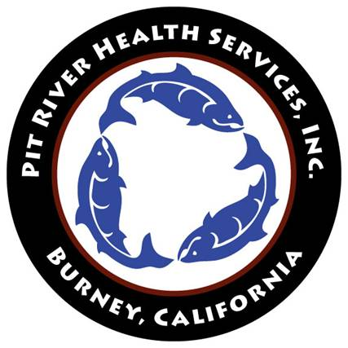  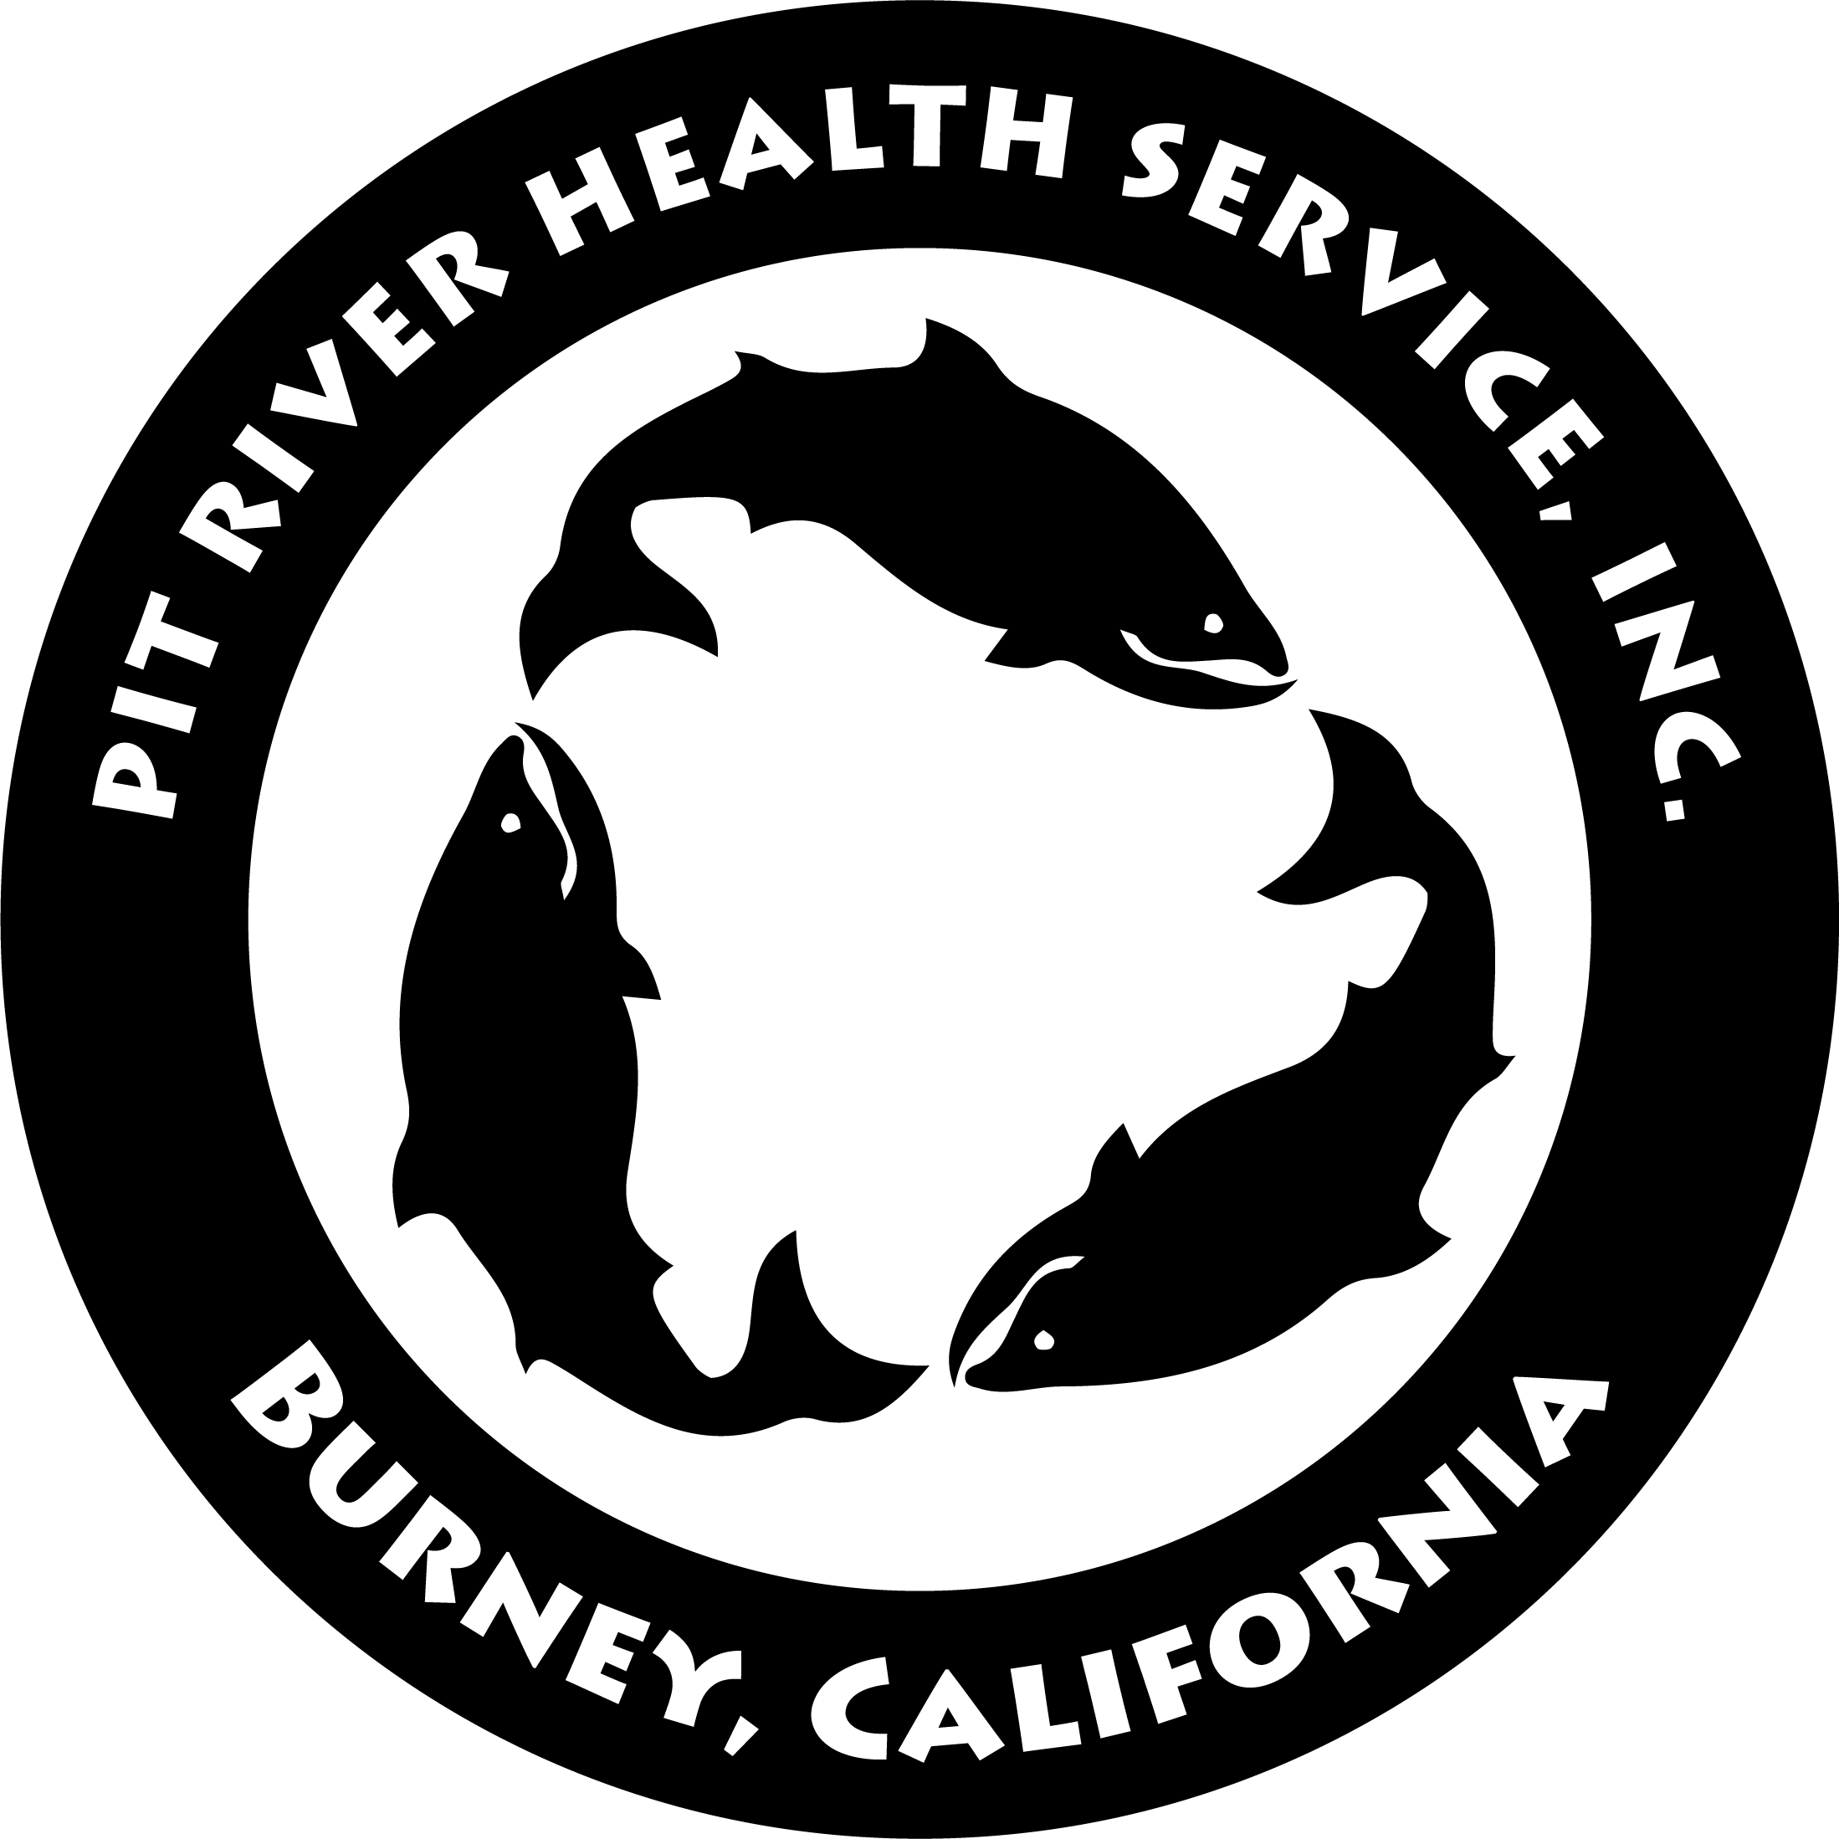 | Administrative Office
36977 Park Avenue |  | 36977 Park Avenue
Burney, CA 96013 |  | Burney, CA 96013
(530) 335-3651 |  | (530) 335-5090
 |  | Fax (530) 335-5241

February 18, 2025
Dear Health Fair Participant,

Pit River Health Service, Inc. in Burney, California will be hosting its annual Good Medicine Health Fair on Friday, June 13, 2025, from 10:00 a.m. – 2:00 p.m. This year's health fair will be hosted at Pit River Casino, 20265 Tamarack Ave, Burney, California. 96013.

The fair will emphasize healthy lifestyles and will offer many learning opportunities for community members from Redding to Alturas. Our Good Medicine Health Fair provides health education, health incentives, and any resources the community may have to offer. Please note the following requirements for attending vendors:
- Must bring tables, chairs, shade tarps and any other needed supplies.
- Must bring anchors weights for shade tarps (Winds typically increase in the afternoon)
- There is no power supply provided for vendors.
- Vendor locations are first come, first serve.

We appreciate your contribution and are very excited to have our community participate in our annual Good Medicine health fair. We look forward to seeing everyone.

If you have any questions, and to RSVP contact Tracy at (530) 335-5090.

Respectfully,

Pit River Health Service, Inc.

